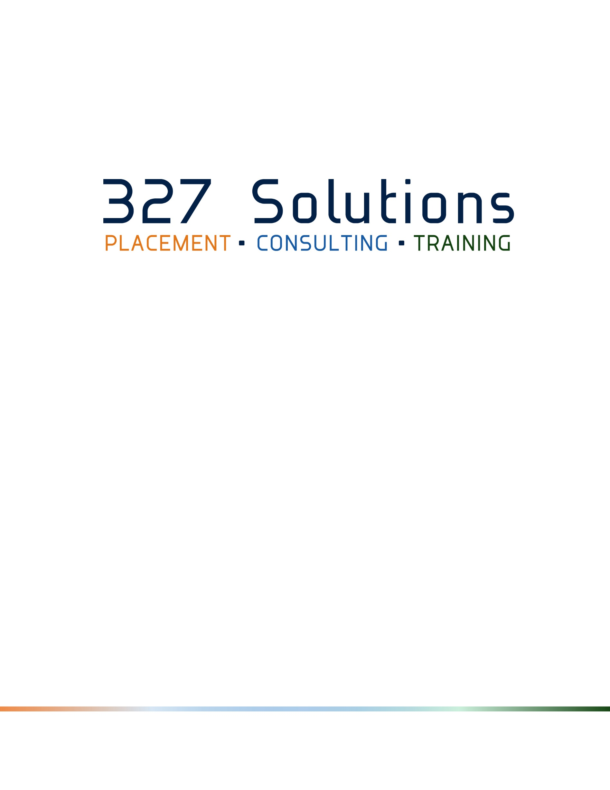
Workshop Catalog
327 Solutions, Inc.
610-646-7070
www.327solutions.com
All Rights Reserved. 2016 ©
Administrative Skills 3
Career Development 3
Human Resources 3
Personal Development 4
Sales And Marketing 4
Supervisors And Managers 4
Workplace Essentials 5
Office 2013 Essentials 5
Office 2013 Advanced 5
Office 2013 Expert 6
Office 365 Essentials 6
Office 2010 Essentials 6
Office 2010 Advanced 6
Office 2010 Expert 7
Office 2007 Essentials 7
Office 2007 Advanced 7
Spanish - Career Development 7
Spanish - Human Resources 8
Spanish - Personal Development 8
Spanish - Sales And Marketing 8
Spanish - Supervisors And Managers 8
Spanish - Workplace Essentials 8
Catalog Updates for 2016 8
Course Example 9

Administrative Skills
- Administrative Office Procedures
- Administrative Support
- Basic Bookkeeping
- Business Writing
- Collaborative Business Writing
- Executive and Personal Assistants
- Meeting Management
- Organizational Skills
- Social Media Training for the Workplace
- Supply Chain Management

Career Development
- 10 Soft Skills You Need
- Assertiveness And Self-Confidence
- Communication Strategies
- Creative Problem Solving
- Developing Creativity
- Digital Citizenship
- Interpersonal Skills
- Negotiation Skills
- Personal Branding
- Project Management
- Telework and Telecommuting
- Time Management
- Women in Leadership

Human Resources
- Business Succession Planning
- Developing a Lunch and Learn Course Outline:
- Entrepreneurship
- Employee Onboarding
- Employee Recruitment
- Generation Gap
- Health and Wellness at Work
- Hiring Strategies
- Human Resource Management
- Measuring Results from Training
- Millennial Onboarding
- Talent Management
- Train-the-Trainer
- Workplace Diversity
- Workplace Harassment
- Workplace Violence

Personal Development
- Anger Management
- Attention Management
- Being a Likeable Boss
- Critical Thinking
- Emotional Intelligence
- Goal Setting and Getting Things Done
- Increasing Your Happiness
- Improving Self-Awareness
- Improving Mindfulness
- Job Search Skills
- Managing Workplace Anxiety
- Motivating Your Sales Team
- Personal Productivity
- Public Speaking
- Social Intelligence
- Social Learning
- Stress Management
- Work-Life Balance

Sales And Marketing
- Body Language Basics
- Call Center Training
- Creating a Great Webinar
- Employee Recognition
- Event Planning
- Internet Marketing Fundamentals
- Marketing Basics
- Media and Public Relations
- Overcoming Sales Objections
- Presentation Skills
- Proposal Writing
- Sales Fundamentals
- Telephone Etiquette
- Trade Show Staff Training

Supervisors And Managers
- Budgets and Financial Reports
- Coaching and Mentoring
- Employee Motivation
- Facilitation Skills
- How To Develop New Managers
- Knowledge Management
- Leadership and Influence
- Lean Process and Six Sigma
- Manager Management
- Middle Manager
- Networking Within the Company
- Office Politics for Managers
- Performance Management
- Supervising Others
- Virtual Team Building And Management

Workplace Essentials
- Appreciative Inquiry
- Business Acumen
- Business Ethics
- Business Etiquette
- Change Management
- Civility in the Workplace
- Conflict Resolution
- Customer Service
- Delivering Constructive Criticism
- Developing Corporate Behavior
- General Team Building
- Handling a Difficult Customer
- Risk Assessment and Management
- Safety in the Workplace
- Teamwork and Team Building

Office 2013 Essentials
- Access 2013 Essentials
- Excel 2013 Essentials
- OneNote 2013 Essentials
- Outlook 2013 Essentials
- PowerPoint 2013 Essentials
- Publisher 2013 Essentials
- Word 2013 Essentials

Office 2013 Advanced
- Access 2013 Advanced
- Excel 2013 Advanced
- OneNote 2013 Advanced
- Outlook 2013 Advanced
- PowerPoint 2013 Advanced
- Publisher 2013 Advanced
- Word 2013 Advanced

Office 2013 Expert
- Word 2013 Expert

Office 365 Essentials
- Excel 365 Essentials
- Lync 365 Essentials
- OneNote 365 Essentials
- Outlook 365 Essentials
- PowerPoint 365 Essentials
- SharePoint 365 Essentials
- Word 365 Essentials

Office 2010 Essentials
- Access 2010 Essentials
- Excel 2010 Essentials
- InfoPath 2010 Essentials
- OneNote 2010 Essentials
- Outlook 2010 Essentials
- PowerPoint 2010 Essentials
- Project 2010 Essentials
- Publisher 2010 Essentials
- SharePoint Designer 2010 Essentials
- Visio 2010 Essentials
- Word 2010 Essentials

Office 2010 Advanced
- Access 2010 Advanced
- Excel 2010 Advanced
- InfoPath 2010 Advanced
- OneNote 2010 Advanced
- Outlook 2010 Advanced
- PowerPoint 2010 Advanced
- Publisher 2010 Advanced
- Visio 2010 Advanced
- Word 2010 Advanced

Office 2010 Expert
- Access 2010 Expert
- Excel 2010 Expert
- InfoPath 2010 Expert
- Outlook 2010 Expert
- PowerPoint 2010 Expert
- Project 2010 Expert
- Word 2010 Expert

Office 2007 Essentials
- Access 2007 Essentials
- Excel 2007 Essentials
- Groove 2007 Essentials
- InfoPath 2007 Essentials
- OneNote 2007 Essentials
- Outlook 2007 Essentials
- PowerPoint 2007 Essentials
- Project 2007 Essentials
- Publisher 2007 Essentials
- Visio 2007 Essentials
- Windows 7 Essentials
- Windows 8 Essentials
- Word 2007 Essentials

Office 2007 Advanced
- Access 2007 Advanced
- Excel 2007 Advanced
- InfoPath 2007 Advanced
- OneNote 2007 Advanced
- Outlook 2007 Advanced
- PowerPoint 2007 Advanced
- Project 2007 Advanced
- Publisher 2007 Advanced
- Visio 2007 Advanced
- Word 2007 Advanced

Spanish - Career Development
- Estrategias de Comunicacion (Communication Strategies)
- Resolucion Creativa De Problemas (Creative Problem Solving)
- Trabajo a Distancia y Desde el Hogar (Telecommuting from home)

Spanish - Human Resources
- Integracion (Onboarding) de Empleados (Integration (Onboarding) Employees)

Spanish - Personal Development
- Aprendizaje Social (Social Learning)
- Manejo de la Ira (Anger Management)
- Inteligencia Emocional (Emotional intelligence)

Spanish - Sales And Marketing
- Conceptos Basicos del Lenguaje Corporal (Body Language Basics)
- Entrenamiento Para Call Center (Training for Call Center)
- Crear Un Gran Seminario Web (Create A Great Web Seminar)

Spanish - Supervisors And Managers
- Gestion del Desempeno (Performance Management)
- Presupuestos e Informes Financieros (Budgets and Financial Reporting)

Spanish - Workplace Essentials
- Atencion al Cliente (Customer Service)
- Como Propiciar Criticas Constructivas (Foster Constructive Criticism)
- Etica Empresarial (Business Ethics)
- Evaluacion-y Gestion de Riesgos (Evaluation and Risk Management)
- Indagacion Apreciativa (Appreciative Inquiry)
- Resolucion de Conflictos (Conflict Resolution)
- Seguridad en el Lugar de Trabajo (Safety in the Workplace)
- Vision Para Los Negocios (Business Acumen)

Catalog Updates for 2016
- Conducting Annual Employee Reviews (Available 3/1/2016)
- High Performance Teams (Inside the Company) (Available 4/1/2016)
- High Performance Teams (Remote Workforce) (Available 7/1/2016)
- Life Coaching Essentials (Available 9/1/2016)
- Multi-Level Marketing (Available 8/1/2016)
- Networking (Outside the Company) (Available 5/1/2016

Course Example

Career Development - 10 Soft Skills You Need
Approximate Time: 7 hours (ILT)
The meaning of Soft Skills can sometimes be difficult to describe. It can be that unique attribute or characteristic that facilitates great communication. It can be the special way that you show confidence in a challenging situation. These and other events can become more easily managed with this great workshop.
With our 10 Soft Skills You Need work shop your participants will begin to see how important it is to develop a core set of soft skills. By managing and looking at the way people interact and seeing things in a new light, your participants will improve on almost every aspect of their career.

Workshop Objectives
Research has consistently demonstrated that when clear goals are associated with learning, it occurs more easily and rapidly. With that in mind, let’s review our goals for today.
At the end of this workshop, participants should be able to:
- Discuss how soft skills are important to success in the workplace
- Understand the 10 key soft skills everyone should have
- Use soft skills to relate more effectively to others in the workplace
- Understand how to use soft skills to communicate, problem-solve, and resolve conflict
- Apply soft skills to specific situations

Getting Started
- Learning Environment
  - Housekeeping Items
- The Parking Lot
- Workshop Objectives
- Participant Materials

What are Soft Skills?
- Definition of Soft Skills
- Empathy and the Emotional Intelligence Quotient
- Professionalism
- Learned vs. Inborn Traits
- Case Study

Soft Skill 1: Communication
- Ways We Communicate
- Improving Non-Verbal Communication
- Listening
- Openness and Honesty
- Case Study

Soft Skill 2: Teamwork
- Identifying Capabilities
- Get Into Your Role
- Learn the Whole Process
- The Power of Flow
- Case Study

Soft Skill 9: Ability to Learn From Criticism
- Wow, You Mean I'm Not Perfect?
- Listen With An Open Mind
- Analyze and Learn
- Clear the Air and Don't Hold Any Grudges
- Case Study

Soft Skill 10: Networking
- Redefining Need
- Identifying Others' Interests
- Reaching Out
- When to Back Off
- Case Study

Wrap Up
- Words from the Wise
- Review of Parking Lot
- Lessons Learned
- Completion of Action Plans and Evaluations
- Recommended Reading

