1 | After installing Filezilla Client, Open program. | 
2 | Select File and then Site Manager. | 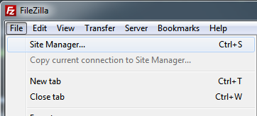
3 | Select New Site and name it 327. | 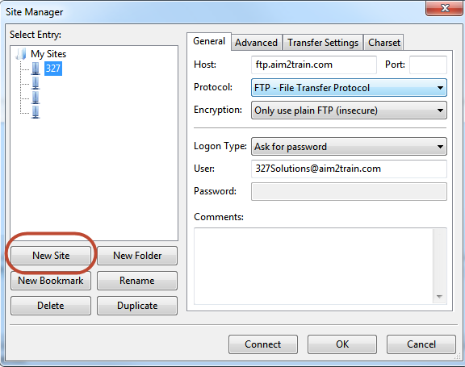
4 | Copy and paste the following information in the fields:  Host: ftp.aim2train.com  User: 327Solutions@aim2train.com
5 | Make sure your Protocol and Encryption settings match the image below.  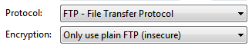
6 | Set Logon Type: to Normal and Enter Password.  Your password is:  327Solutions! | 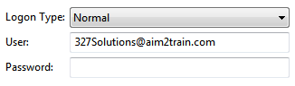
7 | Click OK.
8 | Click the FTP Connection icon and select from the dropdown arrow 327. | 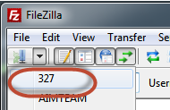
9 | Enter password at prompt and then Click Ok. | 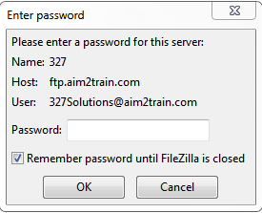
10 | You are connected when you see the remote site folder: Welcome folder | 