Improving Self Awareness
Training Manual

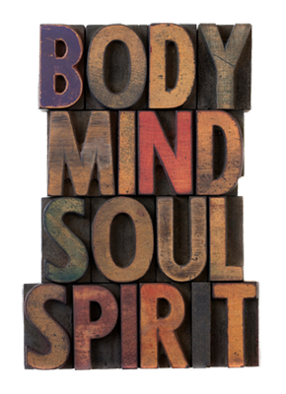

Table of Contents

Module Two: What Is the Self? 7
The Physical Self 7
The Emotional Self 8
The Mental Self 8
The Spiritual Self 9
Module Three: Awareness of the Physical Self 12
Scanning 12
Progressive Relaxation 12
Physical Stressors 13
Exercise 13
Module Four: The Emotional Self 25
Validity of Emotions 25
Utility of Emotions 26
Emotional Arousal 26
Emotional Valence 26
Module Five: Mood Management 30
Emotional Intelligence 30
Categories of Emotion 30
Increasing Arousal 31
Decreasing Arousal 32
Module Six: The Mental Self 36
Thinking Style 36
Stinking Thinking 38
Module Seven: The Spiritual Self 49
Cultivating Positivity 50
Gratitude 51
Module Eight: Limitations of Self Awareness 54
Developing Humility 55
Developing Empathy 56

