January 2, 2017

MEMORANDUM

HOLIDAY SCHEDULE:

You are eligible for six (6) paid Accelerated Instructional Media, Inc. holidays per 2017 calendar year.
- January 2, 2017 (observed)
- May 29, 2017
- July 4, 2017
- Sept 4, 2017
- Nov 23, 2017
- Dec 25, 2017

Compensation and benefit plans evolve as business needs and laws change. The Company reserves the right to modify, rescind, suspend, or cancel any of these plans at any point in time. In the event of such changes, you will be notified as required by law.

Public Notification 2017 Company Holiday Schedule

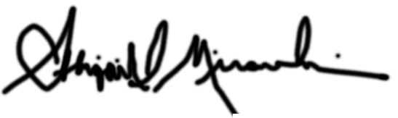Abigail Mirarchi, Principal
_________________

